**Name: Kavindu Dulanjana Perera**

**Contact:** [**Kavindu.dperera@gmail.com**](mailto:Kavindu.dperera@gmail.com)

**+94716184862**

This document contains answers to the questions and features used.

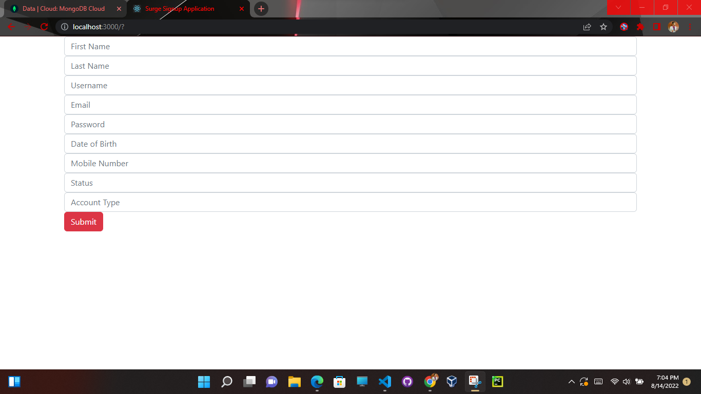**Frontend**

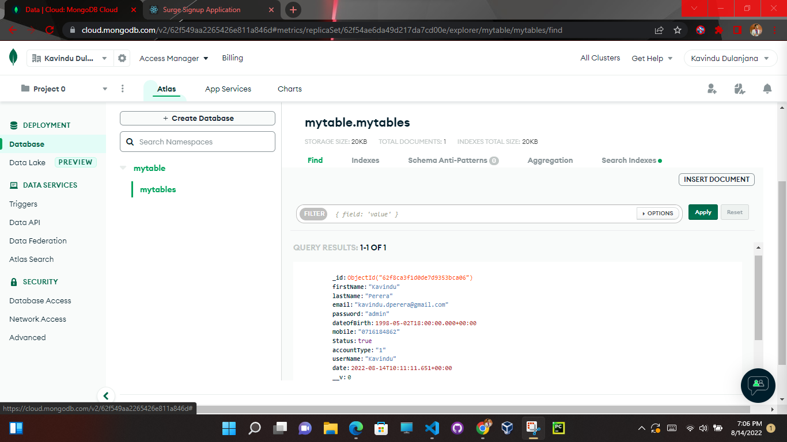**Database (Mongodb)**

**Note:** password salting and hashing has been implemented

**Backend**

>>>Technologies Used

React

Nodejs

Mongoose(Mongodb)

bootstrap

axios

express

bcrypt

>>> Special Features

Password Salting and Hashing

using a .env file to connect to mongodb database

Authentication using JWT web tokens (Feature Removed)

jwtwebtoken

**Questions & Answers**

1. Explaining what design pattern is and how we can use design patterns in projects.

Design pattern is like a template or description that can be used in various situations to solve a given problem. It generally gives a common repeatable or time-tested solution to common problems in software design.

1. What is DTO and explain the use of it.

A data transfer object (DTO) is an object that carries data between processes. It can be used to facilitate communication between two systems such as an API and a server without potentially exposing sensitive information. It reduces the number of calls when working with remote interfaces. The advantage of using DTOs, is that they can help hiding implementation details of domain objects.

1. How are you going to store secrets in an application without exposing it to the internet?

There are many methods of storing secrets the most common way is using an environment file (.env). Also developers can encrypt the secrets and not expose them in source control and manage the encryption keys safely. Also, using credentials-less service access using an IAM authenticated API Gateway as a proxy is also become popular.

1. What is JWT and how does it work?

JSON Web Token (JWT), is an open standard which is used to share security information between two parties. Each JWT contains encoded JSON objects, including a set of claims. JWTs are signed using a cryptographic algorithm to ensure that the claims cannot be altered after the token is issued. Here the authentication server verifies the credentials and issues a Jason web token signed using a private key which the client will then use to access protected resources by passing the JWT in the HTTP Authorization header. The resource server then verifies the authenticity of the token using the public key.

1. What is the difference between SQL and NoSQL databases?

SQL databases are vertically scalable, table-based and are better for multi-row transactions while NoSQL databases are horizontally scalable, document, key-value, graph, or wide-column stores and are better for unstructured data like documents or JSON.

1. Suggest a good state management for frontend application and explain why you recommend it.

The most popular ones are Redux, MobX, and built-in Context API in terms of global state management. In my opinion React's useState is the best option for local state management. It has an excellent tool for providing data across multiple components and it is an easy-to-use tool to manage the state in various scenarios likely to be encountered in enterprise applications: frequent updates, redesigns, the introduction of new features, and more.